Atanas Delevski

ECE 407 HW6

4/9/2020

Question 1: (I did on paper)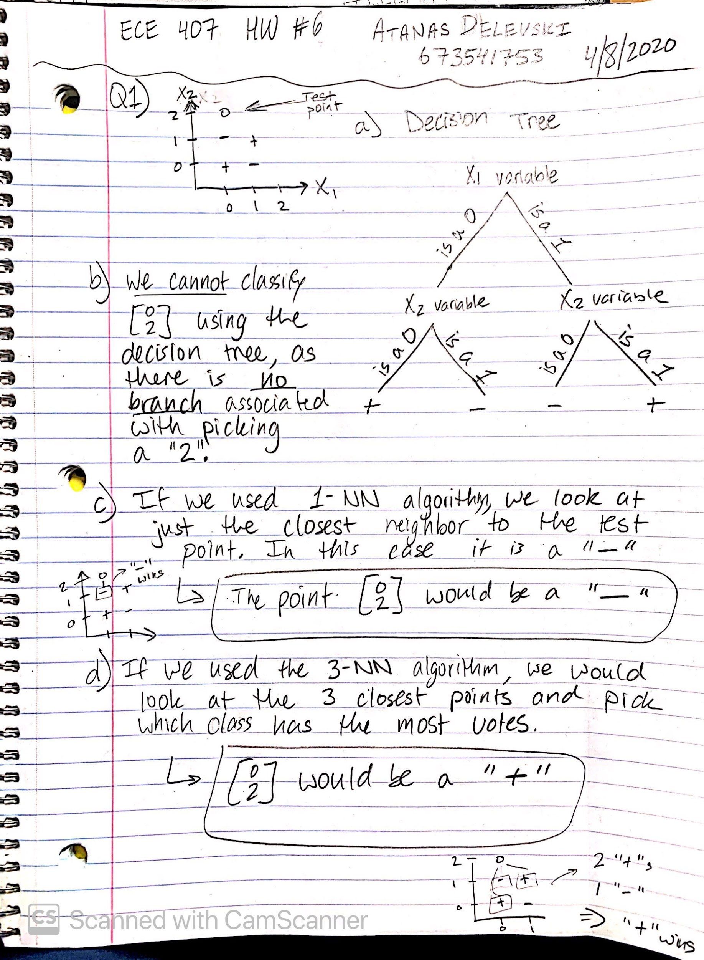

Question 2:

For this question, I used Python.

After opening the excel file in Google Drive to inspect the data, I realized I would need the ***matplotlib*** library to plot and visualize my data. I also realized I would need the ***Pandas*** library to work with the data.

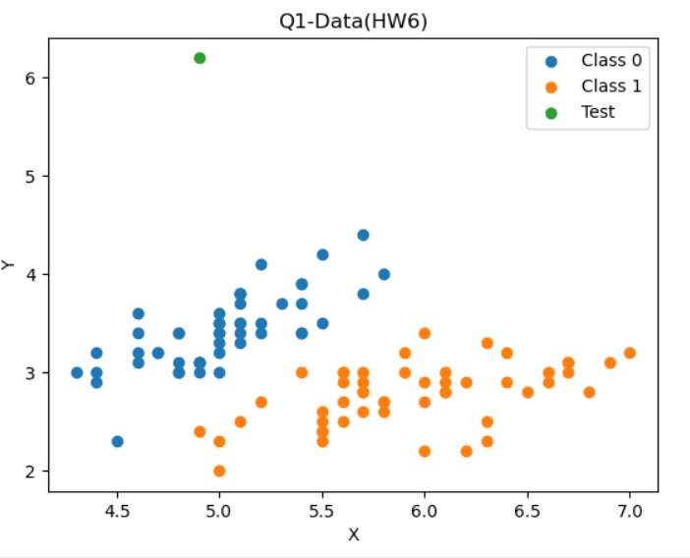

After plotting the data, (and consulting Piazza), I was able to come to the conclusion that the vector [4.9, 6.2] would be classified as Class 0 whether it was 1-NN, or 3-NN, or 5-NN, or even 30-NN as it was so far above Class 0 and away from Class 1, that almost the entire set of Class 0 is closer to the test point than any of Class 1.

Therefore:

Part A) Class 0

Part B) Class 0

My Code is on the following Page.

My Code:

import pandas as pd

import matplotlib.pyplot as plt

data = pd.read_excel('Q1-Data(HW6)(1).xlsx', index_col='Id')

df = pd.DataFrame(data)

ds1 = df[:50] # Class 0

ds1x = ds1['x']

ds1y = ds1['y']

ds2 = df[50:] # Class 1

ds2x = ds2['x']

ds2y = ds2['y']

test_x = 4.9

test_y = 6.2

plt.scatter(ds1x, ds1y, label='Class 0')

plt.scatter(ds2x, ds2y, label='Class 1')

plt.scatter(test_x, test_y, label='Test')

plt.title('Q1-Data(HW6)')

plt.xlabel('X')

plt.ylabel('Y')

plt.legend()

plt.show()